

HEXAWARE CODE&RISE PROGRAM

CODEMANGA_DHAANISH

Inspire Learning Together.



# Team Details

**Team Name** : CodeManga_Dhaanish **Application Name** : Assessment platform

#### Team Members Email ID

**Karthikeyan R**

**[rajukarpagam2004@gmail.com](mailto:rajukarpagam2004@gmail.com)**

**[dineshkumarr2k4@gmail.com](mailto:dineshkumarr2k4@gmail.com)**

**Fazil Ahamed F**

**[ashufazil2005@gmail.com](mailto:ashufazil2005@gmail.com)**

**Kaleemullah A**

**[kaleemullahk333@gmail.com](mailto:kaleemullahk333@gmail.com)**

**Dinesh kumar R**

© Hexaware Technologies. Confidential briefing.

2

**Impact/Potential Value of the Application**



#### Impact of the Application:

* This application integrates adaptive learning, robust security protocols, and real-time monitoring, which collectively enhances the fairness, integrity, and effectiveness of online assessments.
* These features ensure that assessments accurately reflect the true abilities of candidates, thereby bolstering the credibility of the results.

#### Potential Value of the Application:

* This application is positioned to become a top choice for those seeking reliable and secure online assessment solutions.
* By emphasizing fairness, security, and personalized feedback, this application can drive widespread adoption, leading to improved learning outcomes and more precise candidate evaluations.

# The Solution Proposed by your Team

#### Solution Highlights Key Features / Approach

**Comprehensive Assessment Types**

* Cognitive, technical, behavioral, and communication skills assessments
* Holistic evaluations tailored to specific roles and competencies

#### Automation and Efficiency

* Streamlined test administration and real-time reporting
* Reduced time and resources required for candidate evaluation

#### Enhanced Candidate Experience

* Intuitive navigation and mobile accessibility
* Engaging interface for candidates from diverse backgrounds

#### Security and Integrity

* Proctoring options to prevent malpractices
* Stringent data security measures and compliance with privacy regulations

#### Scalability

* Handles high volumes of candidates simultaneously
* Ensures smooth operations during peak assessment periods

#### Customization and Flexibility

* Custom assessment suites aligned with job requirements
* Adaptive testing for personalized assessment experiences

#### Integration Capabilities

* Seamless integration with HR and educational systems
* Streamlined workflows and enhanced efficiency

#### Continuous Improvement

* Feedback mechanisms for ongoing refinement
* Commitment to evolving with industry needs and technological advancements

4

© Hexaware Technologies. Confidential briefing.

1. **Frontend Development**

# Technologies Used

* 1. **File Storage & Management**

**Frameworks/Libraries**: React.js

**Styling**: Tailwind CSS

**Languages**: JavaScript, HTML5, CSS3

**Timer Integration:** JavaScript

1. **Backend Development**

**Frameworks**: Spring Boot (Java) , Django (Python)

**Languages**: Java, Python

**ORMs**: Hibernate(Java), Django(Python) **Database**: PostgreSQL, MongoDB **Authentication**: JWT

1. **AI/ML Integration**

**Libraries**:s OpenCV, PyTorch, Scikit-learn

**Data Processing**: Numpy, Pandas

**NLP**: Hugging Face Transformers, SpaCy, NLTK

**Tools**: Jupyter Notebook

**Cloud Storage**: AWS S3

**File Upload Handling**: Spring Boot Multipart, Django File Upload

* 1. **Proctoring & Real-time Data Processing Libraries**: OpenCV

**Audio Processing**: Librosa

**Real-time Processing & Live Video Streaming**: WebRTC

**Tools**: Ffmpeg

* 1. **Deployment**

**Containerization & Orchestration**: Docker, Kubernate

**CI/CD** : Jenkins, GitHub Actions

**Hosting**: AWS EC2

* 1. **Security**

**Encryption**: TTL/SSL, AES

**Vulnerability Scanning**: OWASP ZAP, Synk

* 1. **Data Storage & Management**

**Data Warehousing**: Amazon Redshift

© Hexaware Technologies. Confidential briefing.

5



### Gen AI Tool Utilization:

**Enhancing Scalability:**

The application leverages Generative AI tools to predict and manage user demand, ensuring that resources are allocated efficiently as the user base grows. This allows the system to scale seamlessly without compromising on performance or user experience.

**Optimizing Performance:**

Generative AI models are employed to optimize backend processes and algorithms, reducing latency and improving the responsiveness of the application. These tools analyze user interactions and adapt the system's performance in real-time, ensuring a smooth and efficient workflow.

**Strengthening Security:**

AI-driven threat detection and mitigation tools continuously monitor for potential security breaches. These tools can proactively identify vulnerabilities, predict possible attack vectors, and implement automated defenses, ensuring the highest level of data protection and system integrity.

This integration of Generative AI tools not only enhances the core functionalities of scalability, performance, and security but also positions the application at the forefront of technological innovation, driving superior outcomes for users.

6

© Hexaware Technologies. Confidential briefing.

# System Architecture, Functionalities and Design Diagram

Sends data



Pulls data

**Model**

* User Model
* Assessment Model
* Proctoring Model
* Analytics Model

Retrieves data

Stores data

Database

7



**View**

* Candidate View
* Educator View
* Administrator View

**Controller**

* User Controller
* Assessment Controller
* Proctoring Controller
* Analytics Controller
* Feedback Controller
* Support Controller

Push data

Enters data



User

(Candidate, Educator, Administrator)

© Hexaware Technologies. Confidential briefing.

**Model View Controller**

**Architecture**

**FUNCTIONAL ARCHITECTURE**

**User Management**

(Authentication, Profile)

**Assessment Management**(Test Creation, question Bank, Time Limits)

**Proctoring & Monitoring**

(Live Video, Noise Detection, Secure Browser)

**AI/ML Services**

(Recommendations, Chatbot, Voice Alerts)

**Data Management**

(File Storage, Database, Data Warehousing)

**Feedback & Reporting** (Feedback Collection, Sentiment Analysis, Report Generation)

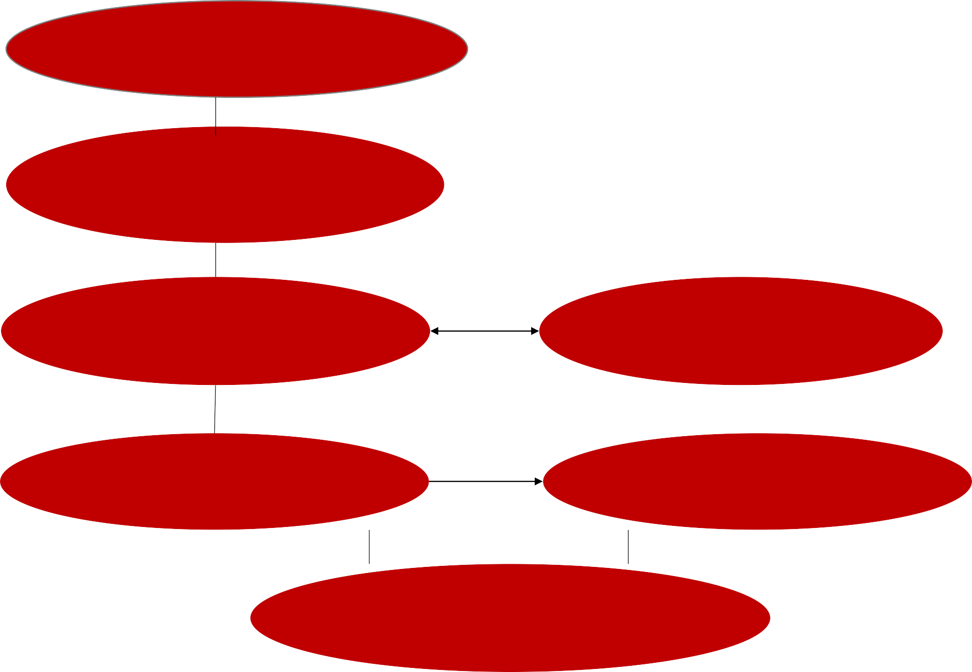

© Hexaware Technologies. Confidential briefing.

**Security & Compliance**

(Encryption, Vulnerability Scanning,

Compliance) 8

# Technical Architecture

What The User Sees & Interacts With HTML, CSS, JavaScript

### Front-end

Request

### API



Response

Contains App Logic Python, Java

### Web Server

Authorization & Authentication JWT

### Security

Amazon S3

### File Storage

PostgreSQL, MongoDB

### Database

**Back-end**

9

© Hexaware Technologies. Confidential briefing.

# Innovation and Creativity



#### Impact of the Application:

* This application integrates adaptive learning, advanced security measures, and real-time monitoring, significantly boosting the fairness, integrity, and efficiency of online assessments.
* These features work together to ensure that assessments accurately reflect candidates' true abilities,

thereby enhancing the credibility of the results.

#### Potential Value of the Application:

* This application is poised to become the go-to solution for those seeking reliable and secure online assessments.
* Its emphasis on fairness, robust security, and personalized feedback can drive broad adoption, leading to improved learning outcomes and more precise candidate evaluations.

# Scalability, Performance and Security

## Scalability:

* **The application is designed to efficiently handle a growing number of users and assessments without**

**compromising performance or reliability.**

* **Its modular and flexible architecture allows for easy integration of new features and seamless expansion to accommodate increasing demand.**

## Performance:

* **The application delivers fast and responsive user experiences through optimized algorithms and**

**streamlined workflows.**

* **Real-time processing capabilities enable immediate feedback and results, enhancing the overall efficiency of the assessment process.**

## Security:

* **Advanced security measures, including encryption and multi-factor authentication, protect sensitive data and maintain the integrity of assessments.**
* **Continuous monitoring and threat detection systems proactively identify and mitigate potential security risks and breaches.**

11

© Hexaware Technologies. Confidential briefing.

# Best Practices and Industry Standards Followed:

### ****Assessment Validity and Reliability:****

**Item Analysis:** Use statistical methods to analyze the reliability and validity of assessment items (questions) and ensure they accurately measure what they are intended to.

**Fairness:** Ensure assessments are free from bias and are fair to all test-takers, considering various cultural, linguistic, and educational backgrounds.

### ****Compliance and Standards:****

### ****Industry Standards:**** Follow relevant industry standards such as IEEE (Institute of Electrical and Electronics Engineers) for software development and ISO (International Organization for Standardization) standards for quality

### management.

**Educational Standards:** Align with educational and assessment standards relevant to the target audience, such as those set by educational institutions or accrediting bodies.

### ****Feedback and Improvement:****

**User Feedback:** Collect and analyze user feedback regularly to identify areas for improvement.

**Continuous Improvement:** Implement a process for continuous improvement based on feedback, technological advancements, and evolving best practices.

### ****Data Security and Compliance:****

**Compliance**: Ensure the platform adheres to relevant data protection regulations such as GDPR, HIPAA, or FERPA, especially when dealing with sensitive assessment data.

**Data Encryption**: Verify that data exchanged between systems is encrypted to ensure secure communication.

© Hexaware Technologies. Confidential briefing.

12

# User Experience

#### Intuitive Navigation

Design a clean, user-friendly interface with simple and consistent navigation. Ensure users can easily find and access assessments, track progress, and view results.

#### Responsive Design

Optimize the platform for all devices (desktops, tablets, smartphones) to ensure a seamless experience, regardless of how users access the platform.

#### Automated Grading and Feedback

Implement automated grading for objective questions and instant feedback to enhance the assessment

experience for both students and instructors.

#### Personalized Dashboards

Provide role-specific dashboards (for students, instructors, and administrators) that display relevant information and tools, improving efficiency and focus.

#### Security and Compliance

Ensure robust data security with features like encryption and role-based access, while also adhering to regulatory

standards like GDPR to protect user data and privacy.

13

© Hexaware Technologies. Confidential briefing.

# Console Output Details

**Figma Prototype Link : <https://tinyurl.com/2km89tvd>**

**Github Link : <https://github.com/Dineshkumar12300/CODE-MANGA_Dhaanish-Assessment-Platform->**

14

© Hexaware Technologies. Confidential briefing.

# Phase 1 - Judging Criteria



* Solution Approach
* Usage of Gen AI tools
* Solution Feasibility
* Technical Approach/Architecture Design
* Innovation and Creativity
* User Experience
* Documentation and Presentation
* Console Output

Thank You

